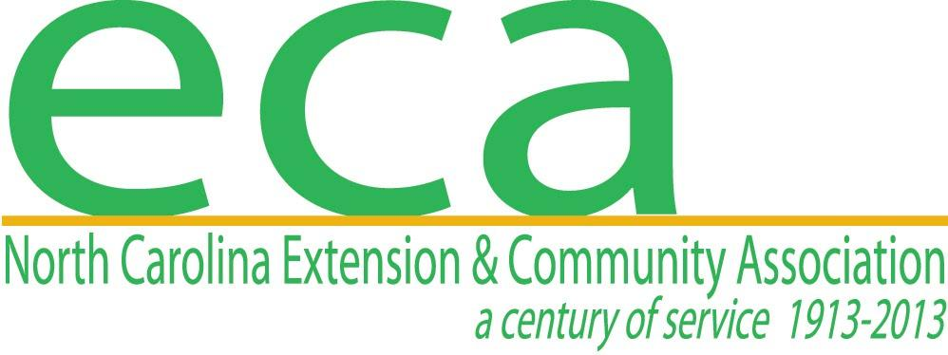
Application must be completed and returned by Feb. 28, 2022
Please mail to: Taylor Cabaniss
Wilson County Extension Service
1806 SW Goldsboro St.
Wilson, NC 27893

THE WILSON COUNTY LOIS RAINWATER EDUCATIONAL SCHOLARSHIP ENDOWMENT APPLICATION

Affiliated with North Carolina Extension & Community Association, Inc.

__________Youth Application
(An individual currently in senior year of high school or in college with no break in her/his formal education)

TO BE PAID THE FOLLOWING FALL TERM

Previous applicants and/or recipients may reapply each year that they remain in school

The purpose of the scholarship is to assist students in obtaining a degree, with priority given to Family and Consumer Sciences major. (Part-time students must carry no less than six (6) hours per semester and full-time students must carry no less than twelve (12) hours per semester).

1. Full Name__________________________________________________________________
First Middle Last

2. Home Address_______________________________________________________________
Street or Route County

____________________________________________________________ Telephone_____________________
City State Zip

3. Social Security Number_____________________ Date of Birth_______________________

4. Intended Major______________________________________________________________

5. Intended College_____________________________________________________________
Have you been accepted ( ) Yes ( ) No

6. Career Objectives____________________________________________________________

_________________________________________________________________________________

7. Marital Status ______single ______married ______divorced ______widowed

8. Parents’ Names and Occupation_________________________________________________

9. Ages of dependent children (if applicable)_________________________________________

Ages of dependent siblings (if applicable)_________________________________________

10. Activities and Honors (Include honors, offices, etc. in school, community and church)

11. Have you had any connection and involvement with Cooperative Extension Service (NCCES)?

Yes ( ) or No ( ). If yes please explain___________________________________________

___________________________________________________________________________

12. Financial Need
a. Approximate family income per year (check one):
( ) below $10,000 ( ) $10,000 to $20,000
( ) $20,000 to $30,000 ( ) $30,000 to $40,000
( ) $40,000 to $50,000 ( ) above $50,000

b. Approximate tuition and fees per year for school/university_____________________

c. Employment__________________________________________________________

d. How do you plan to finance your education__________________________________

13. Scholarship Potential
a. Attach high school or college transcripts
b. Attach a paragraph briefly explaining how receiving this scholarship would help you achieve your educational and/or career goals.

14. Expected date of college/university graduation_____________________________________

15. References – Attach three (3) letters of reference

16. Reviewed by NCECA, Inc. WCLRSE Chairperson

______________________________________ Date____________________________
NCECA, Inc. WCLRSE Chairperson

______________________________________ Date____________________________
Applicant Signature

