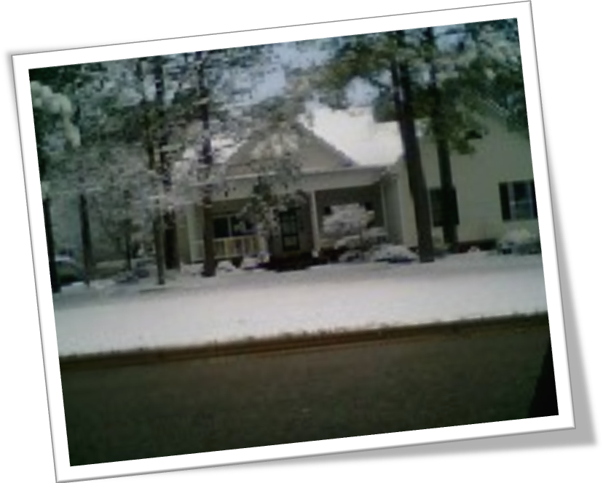
February 26 2014

*
saving $
1806 S. Goldsboro Street, Wilson, NC in Wilson Agricultural Center

Saving Home Energy $
Stay warm all winter and stay cool all summer for less $. Find out how at a workshop on Wednesday, February 26 at 1:30 p.m. Call 252-237-0112 to register for an interactive workshop about saving energy $ at home. Join Wilson Electric, NCSU, Extension’s E-conservation, Wilson Extension & Community Association and Wilson 4-H as they share GREAT techniques for saving energy dollars at home!

